Control Multiple Relays with ESP8266 NodeMCU Web Server
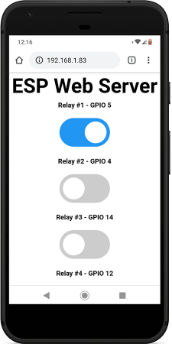
In this section, we’ve created a web server example that allows you to control as many relays as you want via web server whether they are configured as normally opened or as normally closed. You just need to change a few lines of code to define the number of relays you want to control and the pin assignment.
To build this web server, we use the ESPAsyncWebServer library.
Installing the ESPAsyncWebServer library
Follow the next steps to install the ESPAsyncWebServer library:
- Click here to download the ESPAsyncWebServer library. You should have a .zip folder in your Downloads folder
- Unzip the .zip folder and you should get ESPAsyncWebServer-master folder
- Rename your folder from to ESPAsyncWebServer
- Move the ESPAsyncWebServer folder to your Arduino IDE installation libraries folder
Alternatively, in your Arduino IDE, you can go to Sketch > Include Library > Add .ZIP library… and select the library you’ve just downloaded.
Installing the ESPAsyncTCP Library for ESP8266
The ESPAsyncWebServer library requires the ESPAsyncTCP library to work. Follow the next steps to install that library:
- Click here to download the ESPAsyncTCP library. You should have a .zip folder in your Downloads folder
- Unzip the .zip folder and you should get ESPAsyncTCP-master folder
- Rename your folder from to ESPAsyncTCP
- Move the ESPAsyncTCP folder to your Arduino IDE installation libraries folder
- Finally, re-open your Arduino IDE
Alternatively, in your Arduino IDE, you can go to Sketch > Include Library > Add .ZIP library… and select the library you’ve just downloaded.
After installing the required libraries, copy the following code to your Arduino IDE.

Define Relay Configuration
Modify the following variable to indicate whether you’re using your relays in normally open (NO) or normally closed (NC) configuration. Set the RELAY_NO variable to true for normally open os set to false for normally closed.
#define RELAY_NO true
Define Number of Relays (Channels)
You can define the number of relays you want to control on the NUM_RELAYS variable. For demonstration purposes, we’re setting it to 5.
#define NUM_RELAYS 5
Define Relays Pin Assignment
In the following array variable you can define the ESP8266 GPIOs that will control the relays.
int relayGPIOs[NUM_RELAYS] = {5, 4, 14, 12, 13};
The number of relays set on the NUM_RELAYS variable needs to match the number of GPIOs assigned in the relayGPIOs array.
Network Credentials
Insert your network credentials in the following variables.
const char* ssid = "REPLACE_WITH_YOUR_SSID";
const char* password = "REPLACE_WITH_YOUR_PASSWORD";
Wiring 8 Channel Relay to ESP8266 NodeMCU
For demonstration purposes, we’re controlling 5 relay channels. Wire the ESP8266 NodeMCU board to the relay module as shown in the next schematic diagram.
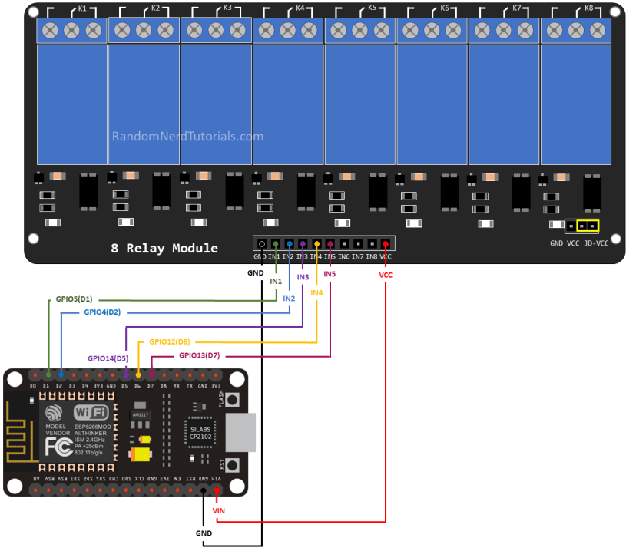
Demonstration
After making the necessary changes, upload the code to your ESP8266.
Open the Serial Monitor at a baud rate of 115200 and press the ESP8266 RST button to get its IP address.
Then, open a browser in your local network and type the ESP8266 IP address to get access to the web server.
You should get something as follows with as many buttons as the number of relays you’ve defined in your code.
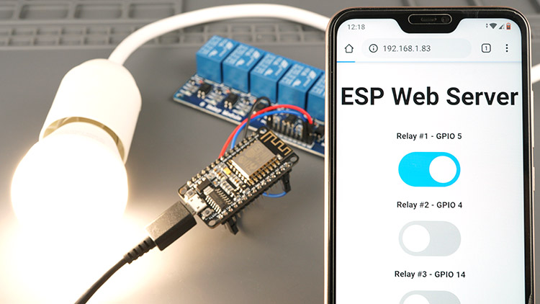
Now, you can use the buttons to control your relays remotely using your smartphone.
Enclosure for Safety
For a final project, make sure you place your relay module and ESP inside an enclosure to avoid any AC pins exposed.

